

T +27 11 404 2480
F +27 11 402 2486
P.O. Box 17009, Doornfontein, Johannesburg, 2O28, RSA
124 Van Beek Street, North Wing, Ground Floor Johannesburg Stadium, New Doornfontein
www.swimsa.org

25th August 2014
From: Chief Executive Officer

To: SSA Affiliate Presidents
SSA Affiliate Secretaries

CC: SSA Executive Members
SSA Committees

RE: TEAM ANNOUNCEMENT – 12th SENIOR AFRICA SWIMMING CHAMPIONSHIPS, DAKAR, SENEGAL 22 - 28 SEPTEMBER 2014

Herewith the team selected to participate at the 12th Senior Africa Swimming Championships being held in Dakar, Senegal from the 22nd – 28th September 2014. On behalf of the SSA Executive Committee, we wish to congratulate all the team members selected and wish them well for the event.

Female |  |  |  |  |  | Male
Gunnell |  | Kelly |  | CGA |  | Ellis |  | Ricky |  | CGA
Johnston |  | Chanel |  | CGA |  | Ryan |  | Christopher |  | CGA
McWilliam |  | Danica |  | CGA |  | Basson |  | Alard |  | EPA
Wessels |  | Michelle |  | FSA |  | Basson |  | Alaric |  | EPA
Chelius |  | Emma |  | KZNA |  | Johannisen |  | Edward |  | EPA
Le Roux |  | Clarice |  | KZNA |  | Justus |  | Calvyn |  | KZNA
Lovemore |  | Tayla |  | KZNA |  | Marais |  | Danie |  | KZNA
McLeod |  | Lindsay |  | KZNA |  | Ronaldson |  | Daniel |  | KZNA
Loubser |  | Marcé |  | NTS |  | Sweeney |  | Ayrton |  | KZNA
Mohr |  | Vanessa |  | NTS |  | Erasmus |  | Douglas |  | NTS
Kat |  | Caitlin |  | WPA |  | Fair |  | Neil |  | NTS
Malan |  | Janneke |  | WPA |  | Meyer |  | Nico |  | NTS
Stephens |  | Megan |  | WPA |  | Muller |  | Caydon |  | NTS
 |  |  |  |  |  | Murray |  | Darren |  | NTS
 |  |  |  |  |  | Ras |  | Ruan |  | NTS
 |  |  |  |  |  | Visser |  | Marko |  | NTS

Team Staff
Mcleod |  | Debbie | Manager | KZNA
Danhauser |  | Delon | Coach | KZNA
Tune |  | Garth | Coach | NWA
Edge |  | Mark | Coach | EPA
Jardine |  | Zaida | Physio

This is a subsidized tour. The cost of the tour, for each team member, is R15, 000, 00. Affiliates must deposit the required amount per team member before departure and fax proof of payment to the SSA Office.

Team members must complete the attached documentation and return to Ms. Daphne Bird and Mr. Dave Norman by Thursday 28th August 2014 daphne@swimsa.co.za, dave@swimsa.co.za Fax: 011 402 2486.

Kindly send the following documents to the SSA office with a copy of the completed Acceptance Form:
- A colour copy of your South African passport.
- A colour passport photo in jpeg format complying with passport photo specifications. http://www.southafrica.dk/fpdb/Consular%20Website/Photo_Specifications.pdf
Acceptance Forms will not be processed until the above documents are in the possession of SSA.

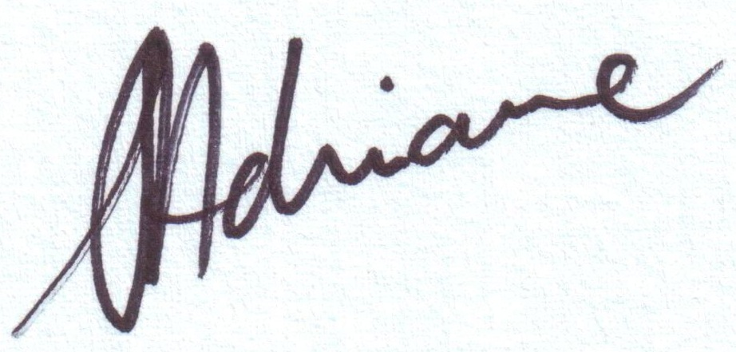
Yours sincerely,

Shaun Adriaanse
Chief Executive

